**COM SCIENCE12 STRING TEST**

<https://www.w3schools.com/CPP/cpp_function_overloading.asp>

Note: string, function, loop(for, while, )

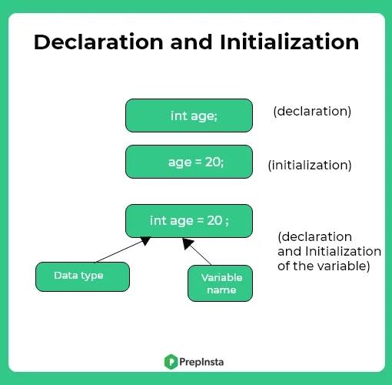

**1.String**

[**https://cplusplus.com/reference/string/string/**](https://cplusplus.com/reference/string/string/)

**1.basic(size of the string)**

**//length of the whole variable(start at 1)**

str.length()

str.size()

//find how many element in an array

int size =sizeof(array)/sizeof(array[0])

//size in byte

Str.sizeof(variable)

**1.1useful function**

-Concatenate strings

<https://www.journaldev.com/37453/string-concatenation-in-c-plus-plus>

-find strings

<https://youtu.be/nkKeA74p3RY>

//find a word by indicating the beginning of index and its length

str.substr(beginning index, length of word you)

//swap str1 with str2

str1.swap(str2)

//find the first location of specific string (left to right)

Str.find(“word”)

//find the last location of specific string (right to left) reverse string

Str.rfind(“word”)

**2.string member function (**[**https://youtu.be/-5LCHcDmXe0**](https://youtu.be/-5LCHcDmXe0)**)**

**//access the index of a string(start at 0)**

**Str.at(index)**

**3.non-member function (**[**https://youtu.be/8lMAMQZRwQM**](https://youtu.be/8lMAMQZRwQM)**)**

**Converting type**

**2.LOOP**

-nested for loop

-for loop

-while loop

<https://youtu.be/EntodYyZjc4>

-do while loop

<https://youtu.be/HcBqJkegqpM>

**3.Functions**

3.1function without return value

//without parameter

void **myFunction()** { // **declaration**  
  // the body of the function (**definition**)  
}

//with parameter ( <https://www.w3schools.com/CPP/cpp_function_param.asp> )

void *functionName*(*parameter1*, *parameter2*, *parameter3*) {  
  // code to be executed  
}

3.2function with return value

int myFunction(int x, int y) {  
  return x + y;  
}

//passing by reference(only when the variable has been initialized)

<https://www.w3schools.com/CPP/cpp_function_reference.asp>

3.3function overloading(multiple functions with same name but different type)

3.4rucursion